
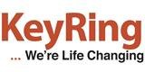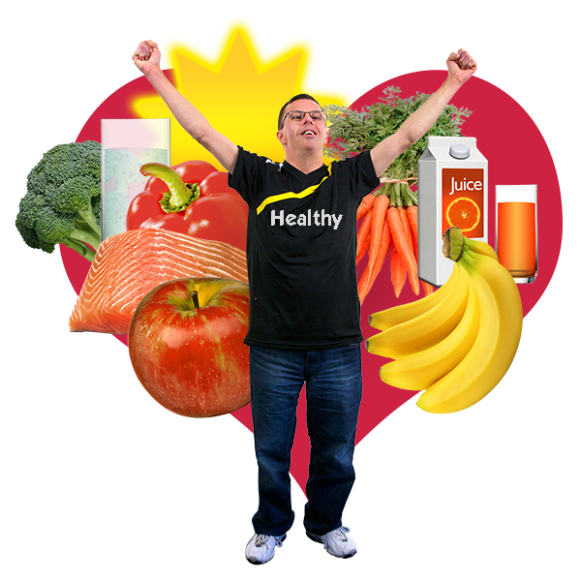
Staying Healthy Questions
Can you tell which of these questions is true or false? Read the questions carefully and then think if the question is true or false.

 | Question | True or false?
1 | If I eat lots of fruit I don’t need to eat any vegetables
2 | Having too much salt in your diet can cause high blood pressure and heart disease
3 | You can lower your blood pressure by doing more exercise and eating a healthy diet
4 | You should drink at least  6 pints of water a day
5 | Exercise can help to reduce the risk of heart disease
6 | Walking to the shops or doing housework can count as exercise
7 | You should only eat vegetables once a week

 | Question | True or false?
8 | You should eat 5 portions of fruit and vegetables every day
9 | Having too much sugar in your diet is not good for you
10 | Fi Fizzy drinks are good for you
11 | Not eating enough fruit, cereals and wholemeal bread may make you constipated
12 | A chocolate orange can count as one portion of fruit
13 | Eating fruit is healthier than eating chocolate
14 | Milk, cheese and yoghurt keep our bones strong
15 | You should only eat small amounts of fat each week
16 | All fruit has some sugar and some fruit has more sugar than others
17 | Too much salt in your diet is not healthy
18 | Crisps and ready meals are very salty
 | Question | True or false?
19 | H Being overweight is good for your heart
20 | Eating healthy foods and taking plenty of exercise is the best way to keep healthy

If you would like more information on healthy eating there are lots of good websites you can look at
http://www.apictureofhealth.southwest.nhs.uk/healthy-life-styles/diet/
https://www.nhs.uk/live-well/eat-well/the-eatwell-guide/
https://www.btm.org.uk/wp-content/uploads/2017/03/Sugar-hi-res.pdf
https://www.btm.org.uk/wp-content/uploads/2018/05/Understanding-Constipation-high-res.pdf
https://www.btm.org.uk/wp-content/uploads/2016/02/KAEOY-Heart-hi-res.pdf
https://www.btm.org.uk/wp-content/uploads/2016/02/Understanding-Diabetes-Hi-Res.pdf

